

*Artificial Intelligence and Data Engineering*

*Industrial* *Applications*

***CarVibes***

________________________________________________________________________

Project Work Package

Luca Caprioli

Martina Marino

Roberta Matrella

Academic Year 2021/2022

The project consists of 8 work packages that are categorized as follows:

– One work package (WP2) is related to state-of-the-art analysis, requirements analysis and system specifications.

–  Four work packages (WP3, WP4, WP5 and WP6) provide the technology components of the project. The activities in these WPs involve research, technology, and development activities.

– One work package (WP7) is concerned with the integration of the technology components from WP3,4,5,6, including the demonstration and validation.

– One work package (WP8) will focus on the dissemination, communication, and marketing of the project’s results.

– One work package is dedicated to Project Management, addressing the alignment of work packages, managing the overall project and the interaction with the public authorities.

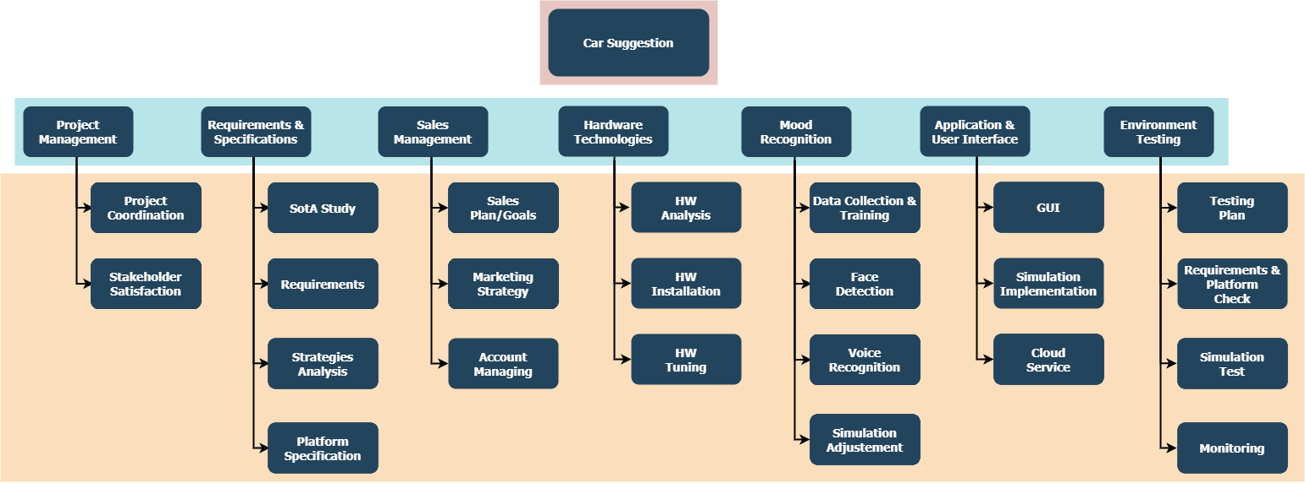

**WP1: Project Management**

WP objective: Overall coordination and project management

In WP1 the overall project will be coordinated, and work will be aligned between work packages. Day to day management according to the team's agreement is coordinated through the Project Management Team. WP1 will also initiate and manage the yearly progress reports. The project leader will act as the primary contact to the commission with respect to legal, financial, and administrative tasks.

**WP2: Requirements and Specifications**

WP objective: Tracking and updating of the state of the art (SotA) from the project start; comparison of project results with SotA; update of system requirements (therein including both hardware and software) compared to the SotA.

The aim of this WP is to provide a detailed update on the state of the art to better define the advances the teams will produce within the project timeframe. The minimum system requirements and specification will also be targeted within WP2.

A careful comparison of the SotA and the new technologies improvements will be performed, including technical aspects (better performances) and the other advantages that the new technologies will bring to the community.

**WP3: Sensing technologies**

WP objective: Development of breakthrough optical sensing technologies for advanced mood monitoring

The technology development and characterization activity done in the framework of WP3 will deliver breakthrough optical sensing technologies with enhanced detection capability. More particularly the work will focus on the development of calibrated light sources, suitable imaging optics, tuneable audio recordings. Dedicated front-end electronics will be developed for detectors signals processing to further optimize the performance of the sensing systems.

**WP4: Data Processing**

WP objective: Develop algorithms and implementations of data processing components.

WP4 is dedicated to signal processing and image processing. This involves sensor related processing to improve the data quality, spectral analysis, feature extraction, pattern recognition and classification, multi modal processing and fusion. The purpose is to enhance the signal quality coming from the sensors in WP3 and to extract relevant data that can be used in visualization tools in WP5.

**WP5: Multimedia technologies**

WP objective: Development of specific multimedia technologies for augmented reality.

The technology research and tuning activity done in the framework of WP5 will deliver specific multimedia technologies for augmented reality presentation. More particularly the work will focus on the development of calibrated audio sources, suitable on-window internal displays, personalized scent-spreading conditioners. As per technologies for WP3, dedicated front-end electronics will be developed for the user to access and use for controlling and navigating the experience.

**WP6: Application SW and User Interface**

WP objective: Any different services developed by the teams need to be used by drivers, they need a friendly graphical interface not only to see the functionalities but also to understand them.

This work package will cover the software development that enables the data exchange and communication between the sensor system, the multimedia system, and the use. Although the specific objectives will depend on the type of sensing and the different uses in response to the specific driver, varying from interaction with the different tools to display information and navigation in the simulation process, to a graphical system that helps navigate the drivers through the different services, all developments must consider matters like integrity, interaction time, privacy etc.

**WP7: Integration and Demonstrators**

WP objective: Integration and demonstration of project results and validation.

The objective of WP7 is to integrate, demonstrate and validate the technologies that are delivered by WP3, WP4, WP5 and WP6. For the validation part, it will consider the requirements that have been defined in WP2.

Although the application tracks have common needs for time-series analysis, face recognition or audio detection, specific demonstrators will be realized to ensure that the components delivered in this project will fulfil the specific application requirements.

**WP8: Sales management**

WP objective: To disseminate and explain the application results and plan a marketing campaign of the product.

During the development of the application, WP8 objective is to reach the audience first with the description, the functionalities, and the innovation of the product to bring up a sense of usefulness and need, then the start of a marketing campaign to place the product on sale, defining the specific market, users and most importantly the innovation it brings in respect to the other competitors.

All these steps need to be taken in full communication with the other WPs through WP1, so to be always updated on the developments to be publicized.